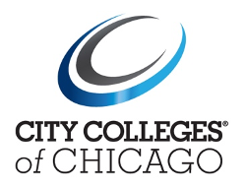
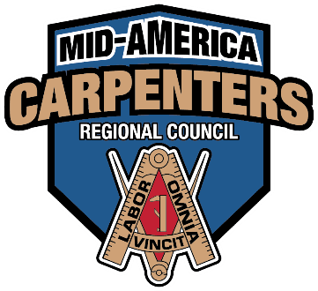

FOR IMMEDIATE RELEASE
December 13, 2021

City Colleges of Chicago and Mid-America Carpenters Regional Council Join Forces to Provide Students With More Opportunity to Move Into Union Apprenticeships Faster
Carpenters can use their work experience and apply it to a degree at Kennedy-King College

CHICAGO—City Colleges of Chicago (CCC) is proud to announce the signing of an Articulation of Prior Learning Transfer Agreement with the Mid-America Carpenters Regional Council Apprentice and Training Fund. This newest agreement between CCC and the Carpenters Union will allow journeymen carpenters to apply their education and training experiences towards a degree at Kennedy-King College, and, for the first time, allow students who successfully complete their basic certificate in carpentry at Kennedy-King to receive advanced placement in the Fund’s pre-apprenticeship program.
"This agreement is a significant step toward ensuring our city's values of equity and inclusion are felt throughout our educational system and our unions," said Mayor Lightfoot. "These two values are absolutely critical to our ability to empower our students as they pursue their education as well as the growth and transformation of our unions—to reflect the experiences of the people they serve. I commend the Carpenters Union for making this incredibly important move and standing up for what's right."
“This is a tremendous advantage for our students,” said Gregory Thomas, President of Kennedy-King College. “The agreement will increase the options for students who successfully complete City Colleges Basic Certificate in Construction Carpentry. Students who qualify can receive advanced placement in the pre-apprenticeship program. It’s a win-win.”
The agreement outlines a clear pathway for participants to earn a degree in Construction Management at CCC, awarding college credit to those with approved prior experience. Another agreement benefit gives those with appropriate prior credits from CCC’s Carpentry program the advantage of placing out of equivalent classes in the pre-apprenticeship program. In addition, the apprenticeship will offer classes designed to meet the needs of CCC carpentry completers to satisfy pre-apprentice requirements and will be available on nights and weekends. This flexibility offers students a broad range of educational opportunities.

“This agreement, which is the culmination of years of hard work, is mutually beneficial for both the Carpenters Union and City Colleges of Chicago students interested in pursuing a career in skilled union trades,” said Gary Perinar, Mid-America Carpenters Regional Council Executive-Secretary Treasurer. “We’re excited to give City Colleges’ students advanced placement opportunities prioritizing diversity, equity, and inclusion to grow and strengthen our union. I thank Mayor Lightfoot and Chancellor Salgado for their leadership and commitment to helping students find opportunities to participate in the construction industry’s best training programs.”
The CCC Construction Management degree requires 65 credit hours. CCC can award up to 30 credit hours toward an Associate of Applied Sciences in Construction Management to participants who successfully complete the coursework. All students must have a high school degree or G.E.D, be a minimum of 17 years old, and live in Chicago.
For more information, visit ccc.edu or call 773-COLLEGE.
###

Media Contacts:
Phil Davidson | Communications Dir. Chicago Regional Council of Carpenters| pdavidson@carpentersunion.org
Veronica Resa | Dir. of Media Relations, City Colleges of Chicago | vresa1@ccc.edu| 773-620-6370 c

